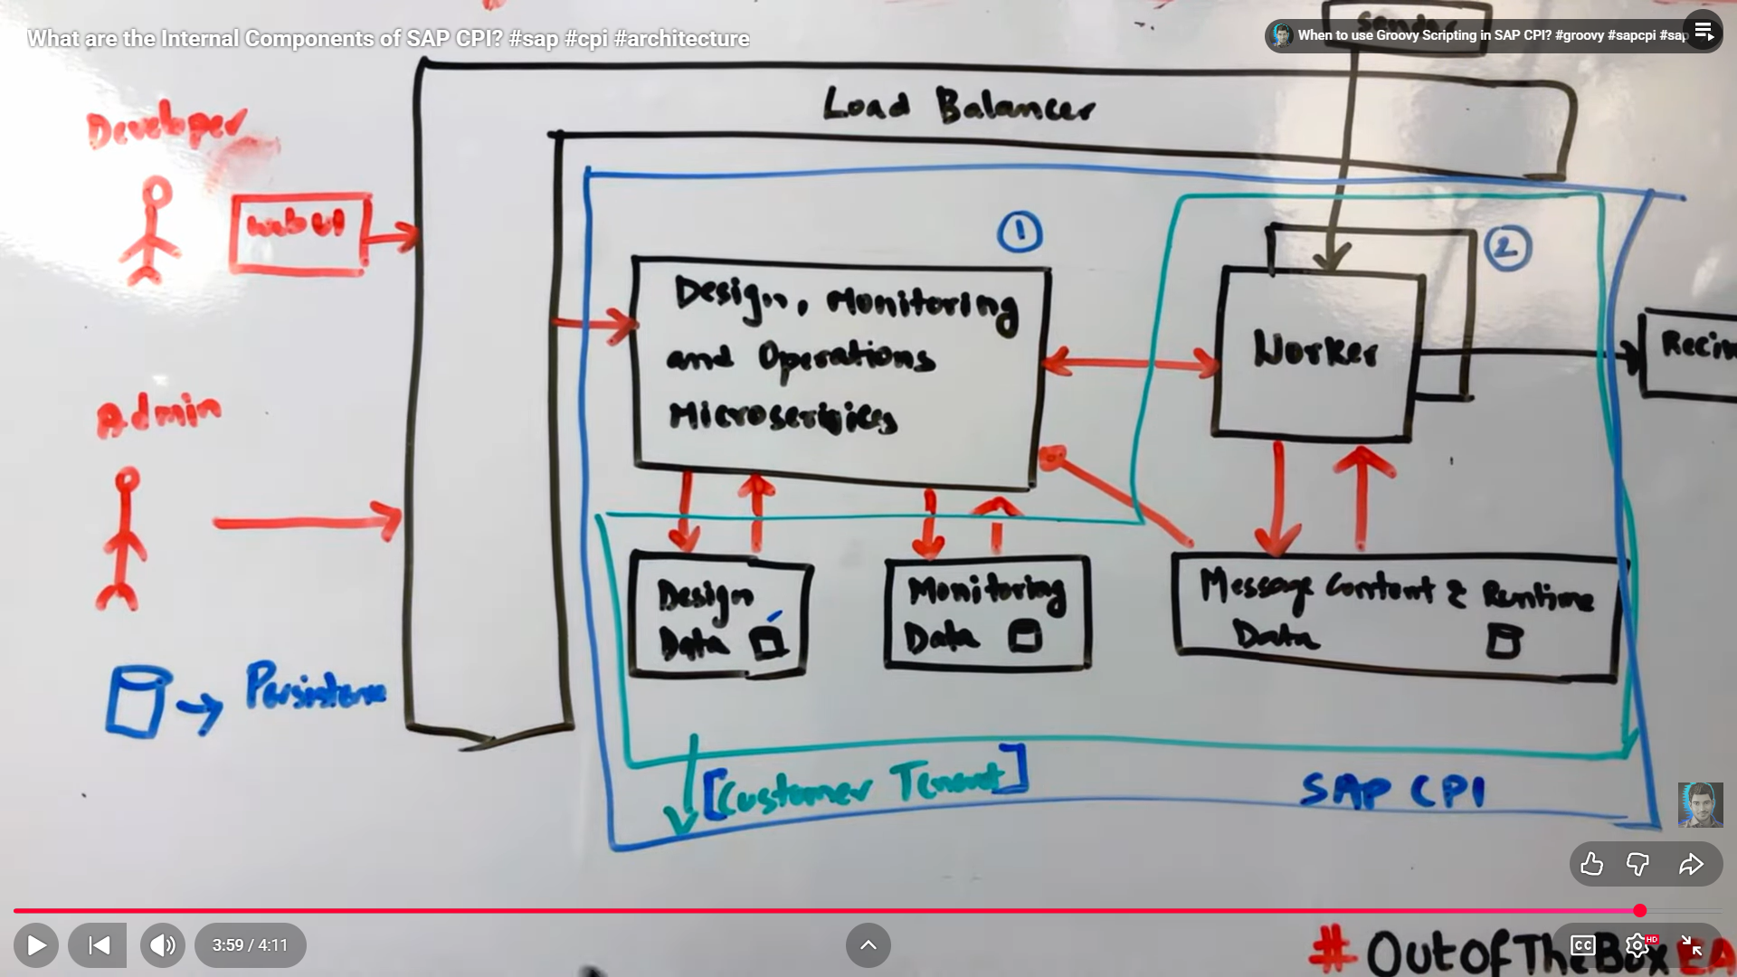
Got it 👍
I’ll explain SAP CPI internal architecture only based on the diagram you shared + the YouTube video, slowly, point-wise, and beginner-safe.
No security deep-dive, no confusion.

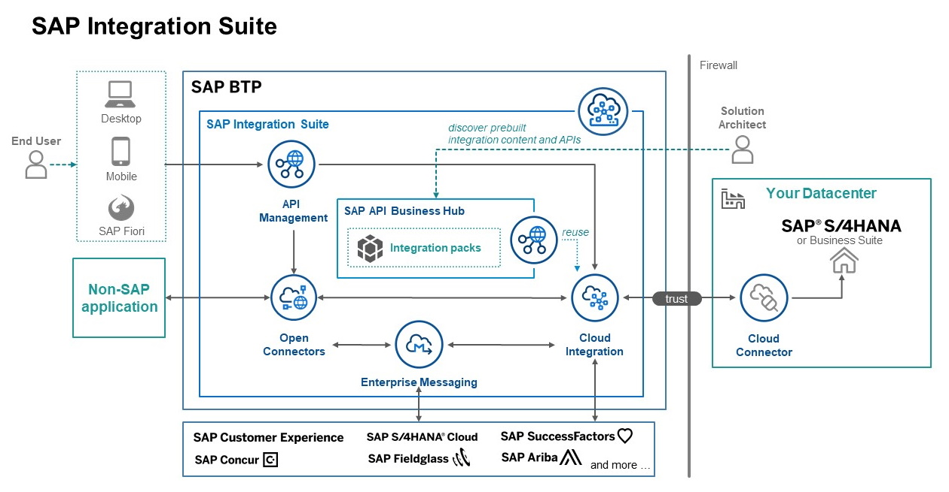
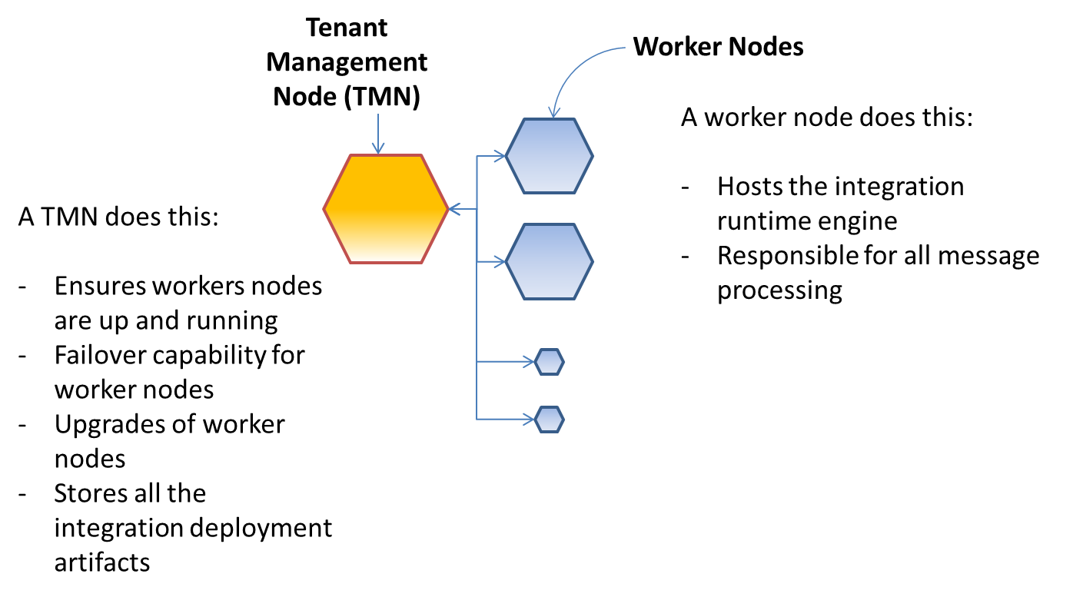
🧠 SAP CPI INTERNAL COMPONENTS (AS IN THE VIDEO & DIAGRAM)
Think of SAP CPI as a factory.

1️⃣ Load Balancer (ENTRY GATE)
What it does
- First component that receives ALL incoming requests
- HTTP, HTTPS, IDoc, OData, etc.
Why it exists
- CPI runs on multiple machines
- Load balancer decides:
  - Which machine (worker) will process the message
Simple meaning
“Traffic police of SAP CPI”

2️⃣ Design, Monitoring & Operations Microservices (CONTROL CENTER)
This is component ① in your diagram
What it handles
- iFlow Design
- iFlow Deployment
- Monitoring
- Operations
- Versioning
When YOU use CPI UI
You are actually talking to this component, not the worker.
Examples
- Open Integration Suite
- Edit iFlow
- Deploy iFlow
- Check message logs
👉 All go here first.

3️⃣ Design Data Store (PERSISTENT)
Stores:
- iFlow definitions
- Packages
- Artifacts
- Versions
Key point
- NOT runtime
- Used only for design-time
👉 If worker crashes, design data is safe.

4️⃣ Monitoring Data Store (PERSISTENT)
Stores:
- Message logs
- Error details
- Processing time
- Status (Completed / Failed)
Used by:
- Monitor tab
- Message Processing view
👉 That’s why you can see logs after execution.

5️⃣ Worker Node (RUNTIME ENGINE)
This is component ② in your diagram
MOST IMPORTANT PART
What worker does
- Executes iFlows
- Runs adapters
- Runs routers
- Runs content modifiers
- Runs Groovy scripts
- Sends messages to receiver systems
Very important rule
Design node NEVER executes messages
Worker ALWAYS executes messages

6️⃣ Message Content & Runtime Data Store
Stores:
- Message payload
- Headers
- Properties
- Runtime context
Lifetime
- Exists only while message is running
- Deleted after processing
👉 This is why data is not permanent unless logged.

7️⃣ Receiver Systems (END SYSTEMS)
Examples
- SAP S/4HANA
- SAP ECC
- Non-SAP systems
- APIs
- Databases
CPI role
- Transform
- Route
- Send data

🔁 COMPLETE FLOW (VERY SIMPLE)
Sender
↓
Load Balancer
↓
Worker Node
↓
iFlow Logic (Router, Content Modifier, Mapping)
↓
Receiver
Meanwhile:
- Design & Monitoring Microservices:
  - Control
  - Observe
  - Store logs

🧩 WHY SAP CPI IS BUILT LIKE THIS
Separation of concerns
Layer | Responsibility
Design | Create & manage iFlows
Runtime | Execute messages
Persistence | Store logs & artifacts
Benefits
- Scalability
- Stability
- Multi-tenant support
- Zero downtime deployments

🔥 INTERVIEW-LEVEL UNDERSTANDING
Q: Where does iFlow execute?
👉 Worker Node
Q: Where is iFlow stored?
👉 Design Data Store
Q: Where are logs stored?
👉 Monitoring Data Store
Q: Who handles UI?
👉 Design, Monitoring & Ops Microservices

🧠 HOW THIS CONNECTS TO YOUR CONFUSION EARLIER
Why HTTP issues were confusing?
Because:
- HTTP hits Load Balancer
- Then Runtime security
- Then Worker
- Not directly your iFlow
👉 That’s why errors happen before iFlow runs

🟢 WHAT YOU SHOULD REMEMBER (EXAM + PROJECT)
- CPI = Microservices architecture
- Design ≠ Runtime
- Worker = Execution
- Data stores are separate
- Load balancer is always first

⏭️ NEXT (YOUR CHOICE)
Reply with one number only 👇
1️⃣ Explain where adapters live in this architecture
2️⃣ Explain where Content Modifier / Router executes
3️⃣ Explain why Groovy runs only on worker
4️⃣ Continue Phase-2 learning using this architecture
I’ll continue exactly at your comfort level 👍
v 26
we can change version only by going in DRAFT section
go to previous version and ok

Here’s a clear summary of what the YouTube video at index 26 (SAP CPI Integration Catalog / Internal Components) is about — based on available info and typical content from that video playlist — explained in simple, structured points you can use for learning or revision.

🎥 Video Overview: SAP CPI – SAP Integration Catalog & Internal Components
📌 This video is part of a SAP CPI tutorial playlist. It explains the internal architecture and components of SAP CPI (Cloud Integration) — how CPI works under the hood and how different pieces fit together. (YouTube)
The focus is on:
- How messages flow
- What components are involved
- Where integration logic runs

🧠 Key Concepts Covered in the Video

✅ 1. SAP CPI Architectural Layers
SAP CPI architecture can be thought of in three main functional layers:
🟩 Integration Layer
- Where integration flows (iFlows) are designed and executed.
- Contains components like:
  - Sender Adapter (receives data)
  - Message Mapping
  - Receiver Adapter (sends data out) (mindmajix)

🟦 2. Connectivity Layer
- Enables communication between systems.
- Uses adapters/connectors for different protocols (HTTP, SFTP, OData).
- Handles security and connectivity logic. (mindmajix)

🟥 3. Process Layer
- Contains tools like the Process Designer for building integrations visually.
- Provides monitoring/analytics to see integration messages and errors. (mindmajix)

🔧 Core Components Explained
Here are the important CPI parts the video explains:

🔹 Integration Flows (iFlows)
- The core of SAP CPI.
- Defines data routing, transformation, and logic.
- Designed in the graphical editor.
- Contains steps like Sender, Mapping, Logic, Adapter, Router, etc. (mindmajix)

🔹 Adapters
- Connect CPI to external systems.
- Examples:
  - HTTP Adapter
  - SFTP Adapter
  - OData
  - JDBC
  - Mail
- Each adapter supports specific protocols. (mindmajix)

🔹 Messaging Infrastructure
- Ensures reliable delivery between systems.
- Uses:
  - Queues
  - Topics
  - Persistence for message storage until delivery. (mindmajix)

🔹 Data Mapping & Transformation
- Converts data formats and structures.
- Helps bridge data between different systems (for example, XML → JSON). (mindmajix)

🔹 Security
- CPI supports a range of data protection and authentication features:
  - TLS / HTTPS encryption
  - Access control
  - Message-level encryption
  - Identity integration (SAML, OAuth) (mindmajix)

🧠 High-Level Understanding
Here’s what the video is teaching you:
✔ SAP CPI is not just one box — it has multiple layers and components
✔ iFlows are executed by a runtime engine
✔ CPI uses a messaging layer to reliably send data
✔ Adapters let CPI talk to many system types
✔ Mapping allows different formats to be translated
✔ Security ensures safe transport and access (YouTube)

📌 Why This Matters for You
Understanding this architecture helps when:
✔ You design integrations
✔ You troubleshoot message failures
✔ You decide where logic should run (control vs execution)
✔ You explain CPI behavior in interviews/projects

🧠 Quick Summary (Exam-Ready)
Component | Purpose
Sender Adapter | Receives data from source
Message Mapping | Transforms format or structure
Receiver Adapter | Sends data to target
Messaging Infrastructure | Reliable delivery
Integration Flow | Integration logic
Security Layer | Protects communication
Monitoring | Logs & manages messages

✅ Takeaway (in simple words)
SAP CPI is a cloud middleware that integrates systems using iFlows. It has multiple layers — integration, connectivity, and process — each responsible for different parts of the integration lifecycle. CPI handles adapters, messaging, transformation, security, and monitoring in a scalable cloud environment. (YouTube)

If you want, I can also give you a diagram you can draw on paper or a one-page cheat sheet based on this video’s concepts. Just ask!

